Embargo until June 13th 10AM EDT/4PM CEST

The BLUESOUND HUB Begins Retail Availability
Gradual roll out of the product to start in North America

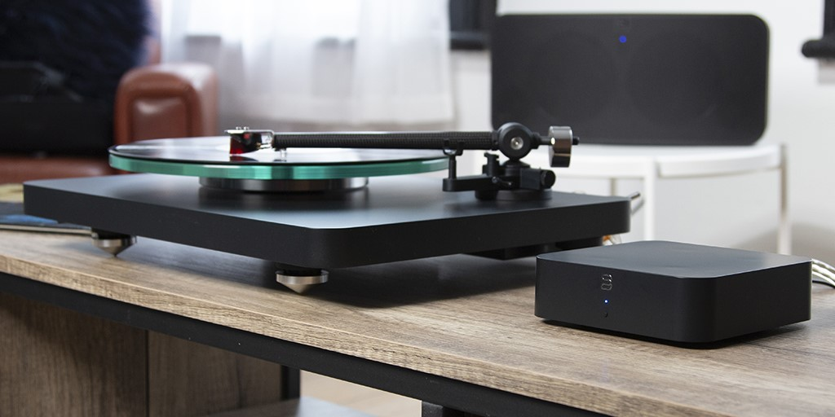
“Bluesound HUB with turntable and PULSE 2i connected”
Toronto, ONTARIO, CANADA JUNE 13, 2022 – Bluesound, makers of hi-fidelity multi-room streamers and speakers, today announces retail availability of the Bluesound HUB Wireless Audio Source Adapter and Network Pre-amp. This versatile network accessory adds non-BluOS audio sources to the BluOS ecosystem, making turntables, TVs, and CD players accessible to Bluesound players for multi-room playback. The HUB is now available for purchase in North America with products starting to ship to consumers the week of June 20, 2022. Availability in the rest of the world will follow at the end of June and the UK in mid-July. The Bluesound HUB will retail for USD $319 / EUR €349 / GBP £309 / CAD $419.

The HUB complements an existing Bluesound ecosystem as a network accessory that takes the audio signal from analog or digital sources and transmits them to Bluesound players on the same WiFi network. Users can select the HUB as an input source in the BluOS Controller app before choosing the Bluesound player where the audio will be sent for playback. Up to 5 sources can be connected to the HUB and two streams, 1 analog and 1 digital, can be simultaneously transmitted from the HUB for dual-zone playback. Grouping is also possible for any stream originating from the HUB.
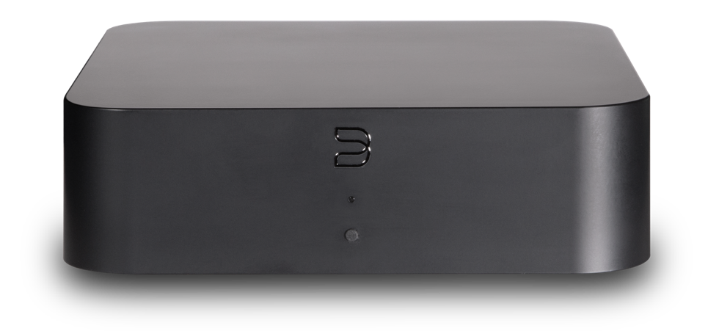
“Bluesound HUB from the front”
Key Features:
- Networked Audio Source-sharing with BluOS™
- HDMI ARC, Coax Digital, TOSLINK Optical, Analog RCA, MM Phono Inputs
- Dual-band Wi-Fi & Gigabit Ethernet Connectivity
- USB-C Powered
- Low-noise MM Phono Stage
- Control via BluOS app
- Black Matte Finish

About bluesound
An alliance of audiophiles. We are the designers, engineers and individuals who have spent our lives in the music industry. Our founders helped pioneer HiFi in the 70s – innovation and the pursuit of perfection in audio runs deep in our collective DNA. Bluesound’s sole mission is to create innovative wireless audio products and technologies that allow for the most true-to-live performance music reproduction possible, utilizing the most advanced, state-of-the-art digital technology.

Contacts

Corporate Contact
June Ip
Marketing, Bluesound
media@bluesound.com

US Media Relations
Jeff Touzeau (OLEX Communications – US/Canada)
+1 914-602-2913
jeff@olexcommunications.us

UK Media Relations
Steve Dalton (OLEX Communications – UK)
+44 (0) 7748-117-864
steve@olexcommunications.co.uk

Links
Website: https://bluesound.com
Images: https://brandlibrary.lenbrook.com/portals/bluesound
Facebook: https://facebook.com/bluesound.hifi
Twitter: https://twitter.com/bluesoundhifi
Instagram: https://instagram.com/bluesoundhifi

# # #

